1. Bagging (Bootstrap Aggregating)
Bagging, short for Bootstrap Aggregating, is an ensemble learning technique designed to improve the stability and accuracy of machine learning algorithms, particularly complex models like decision trees. It reduces variance and helps to avoid overfitting.
The process works in two main steps:
- Bootstrapping: Given a standard training set of size $n$, the algorithm generates multiple new training sets (samples) by randomly drawing $n$ examples from the original dataset with replacement. Because it draws with replacement, some original examples may appear multiple times in a single sample, while others may not appear at all.
- Aggregating: A base model (like a decision tree) is trained independently on each of these bootstrap samples. Once all models are trained, their predictions are combined. For regression tasks, the predictions are averaged. For classification tasks, the final prediction is determined by a majority vote.
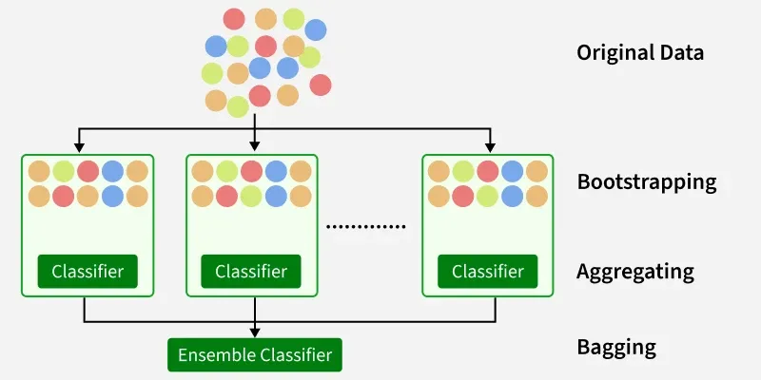

Decision Tree vs. Rand om Forest
A Random Forest is essentially a collection (ensemble) of Decision Trees trained using Bagging, with an additional layer of randomness. Here is how they compare:
Feature | Decision Tree | Random Forest
Architecture | A single tree structure. | An ensemble of many decision trees.
Variance | High. Small changes in training data can result in a completely different tree. | Low. Averaging multiple trees stabilizes the model and reduces variance.
Overfitting | Highly prone to overfitting, especially if allowed to grow deep without pruning. | Robust against overfitting due to the aggregation of multiple diverse models.
Training Speed | Fast. | Slower, as it must construct and query multiple trees.
Interpretability | High (White Box). You can easily trace the path from the root to a leaf to explain a prediction. | Low (Black Box). It is difficult to trace the logic across hundreds of combined trees.

3. Out-of-Bag (OOB) Error
OOB Error is a method of measuring the prediction error of a Random Forest (or any Bagging model) without needing a separate validation dataset.
When you create a bootstrap sample of size $n$ with replacement, the probability that any specific data point is not chosen is ${(1-\frac{1}{n})}^{n}$. As $n$ grows large, this mathematical limit approaches $\frac{1}{e}$ , which is approximately $0.368$.
This means that for every tree in the forest, about 36.8% of the original data is left out of its training sample. These left-out instances are called Out-of-Bag (OOB) samples.
- Because the tree never saw this OOB data during training, it can be used to test the tree's accuracy.
- The OOB Error is calculated by passing each data point through only the specific trees that did not use it during training, aggregating those predictions, and comparing them to the true labels. This provides a highly accurate, unbiased estimate of how the model will perform on unseen data.

4. Why Random Forest Reduces Overfitting
A single decision tree overfits by memorizing the noise and outliers in its specific training data. Random Forest prevents this through two mechanisms:
- Bagging (Row Randomness): Because each tree is trained on a different bootstrap sample, each tree learns a slightly different perspective of the data and memorizes different noise. When you average their predictions, the true signal reinforces itself, while the uncorrelated noise cancels out.
- Feature Randomness (Column Randomness): If one specific feature is overwhelmingly predictive, every single tree in a standard Bagging setup would likely use that feature for its first split, resulting in highly correlated trees. Random Forest prevents this by restricting each tree to only choose from a random subset of features (often $\sqrt{p}$ where $p$ is the total number of features) at each split. This forces the model to explore weaker features, ensuring the trees are highly decorrelated. Averaging decorrelated trees drastically reduces the variance of the final model without substantially increasing the bias.

5. Feature Importance
Because Random Forests are essentially "black boxes," Feature Importance is a metric used to regain some interpretability. It measures how much each input variable contributes to the model's overall accuracy. In Random Forests, this is typically calculated in two ways:
- Gini Importance (Mean Decrease in Impurity): Every time a node splits on a specific feature, the model calculates how much that split decreased the "impurity" (like Gini Impurity or Entropy) of the child nodes compared to the parent node. The algorithm tracks this across all trees in the forest. The features that result in the largest total decrease in impurity across the entire forest are considered the most important.
- Permutation Importance: This method calculates the model's OOB accuracy, and then takes a single feature (e.g., "Age") and randomly shuffles its values across the OOB data. This destroys any relationship between that feature and the target variable. The model then predicts again. If the accuracy drops significantly after shuffling, it means the model heavily relied on that feature, making it highly important. If the accuracy barely changes, the feature wasn't contributing much.

